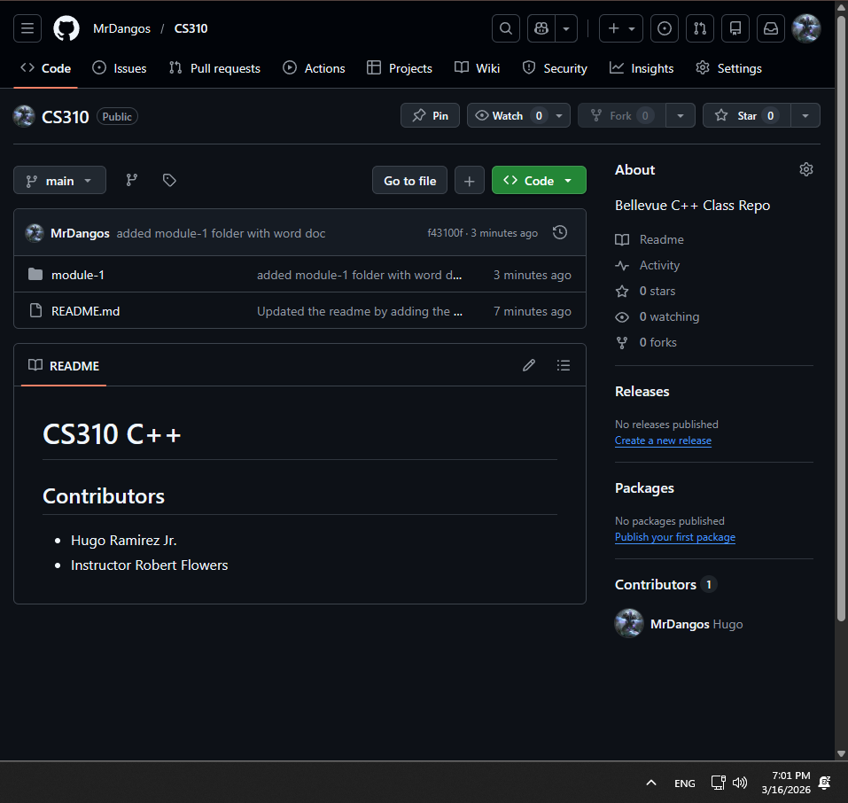

Repo Link: https://github.com/MrDangos/CS310
ReadMe: https://github.com/MrDangos/CS310/blob/main/README.md

